The Guide to

Functional Testing

Contents

1. Software Development Life Cycles
2. Introduction to Software Testing
3. Different Types of Functional Testing
4. Stages of Testing
5. Scenario Based Questions
6. Agile Methodology

Software Development Life Cycle

Q. What do you mean by Software Development Life Cycle (SDLC)?

Ans.

Introduction to Software Testing

***Q. What are the advantages and Disadvantages of Manual Testing?***

**Ans.** Advantages of Manual Testing

* Preferable for products with a short life cycle.
* Saves time, money, and resources.
* Ensure the error-free product.
* Usable for exploratory testing, ad hoc testing, and usability testing.
* No need to change the entire code to make minor changes.
* Get accurate user interface feedback.
* Ability to handle difficult use case situations in a better way.
* GUI testing can be done accurately.
* Highly reliable.
* Make user-friendliness better.
* Easy to learn for new testers.

Disadvantages of Manual Testing

* Not suitable for time-bounded projects and large organizations
* More prone to human errors and mistakes
* Less efficient as the choice of recording the testing process is not available
* Less Reliable
* Regression testing is time-consuming
* Does not cover all the aspects of testing
* Load testing and performance testing can be performed manually
* More expensive in the long run process

***Q. What types of manual testing are there?***

During the test life cycle, there are different manual testing types or manual testing techniques that may be used. Following is a list of them:

* Black Box Testing
* White Box Testing
* Unit Testing
* System Testing
* Integration Testing
* Acceptance Testing

***Q. Who is a manual tester? Explain its roles and responsibilities.***

The manual tester is a professional who conducts quality checks on software applications without using automation tools or scripting. In essence, the speciality involves manually checking software for errors and fixing them. Manual testers must have the appropriate skills and be able to meet the company's requirements.

**Manual Tester Roles and Responsibilities**

* Analyzing client requirements.
* Reviewing written code for compliance with project specifications.
* Creating a test environment for executing test cases.
* Establishing quality assurance strategies and organizing phased testing.
* Organizing and conducting review meetings.
* Executing and analyzing test cases.
* Detecting and fixing bugs.
* Monitor system errors and discuss them with colleagues.
* Keeping in touch with the test manager, etc.

Q. **Describe the manual testing process.**

Among the steps involved in manual testing are:

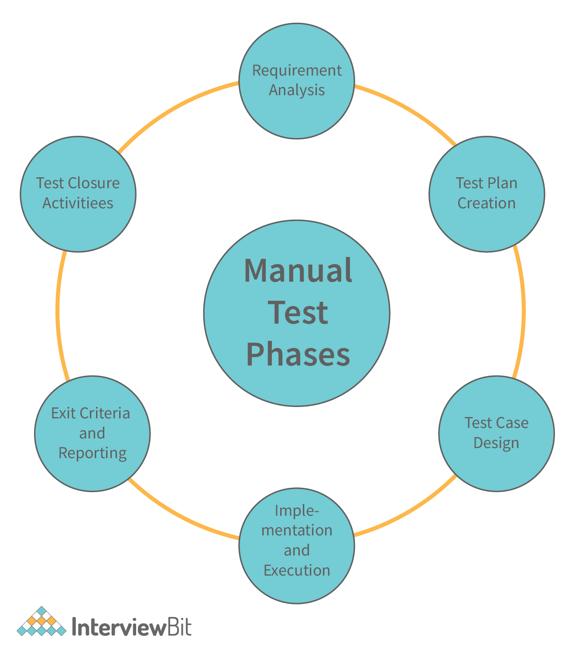

* Requirement analysis
* Test plan creation
* Design test scenarios and test cases
* Test execution and defect reporting
* Evaluating exit criteria and reporting
* Test closure activities

Stages of Testing

***Q. Can you tell me what the different levels of manual testing are?***

Different levels of testing can be carried out during the development process. Multilevel testing facilitates the identification of bugs early in the development process. The four levels of testing are as follows:

**UAT**

**System Testing**

**Integration Testing**

**Unit Testing**

* **Unit testing:** Essentially, it is a way of testing logically isolated pieces of code within a system called units. Mainly, it focuses on the standalone module's functional accuracy.
* **Integration Testing:** Software testing at this level involves combining and testing individual units to see if they work together as they should. This test focuses on the interface between modules.
* **System Testing:**It involves testing all components of the product as a whole to ensure that overall product requirements are met. The types of system testing include regression testing, usability testing, and functional testing.
* **User Acceptance Testing:** Acceptance testing, also known as UAT (User Acceptance Testing), is the final step in the software testing process. This test determines if the software is ready for release.